Musaab Alfalahi

APPLIED SCIENCE UNIVERCITY

Phplist Installation Manual

Contents

Introduction 2

System Requirements 2

Installation Procedure 3

Testing and Verification 5

Technical Support and Contact Information 5

# Introduction

phpList is a free tool that helps you manage email lists and send out emails easily. It's like a friendly assistant for sending messages to lots of people at once. This guide is like a step-by-step map to help you set up phpList on your computer. Whether you're good with computers or just starting, the guide is here to make it simple. You just need to know a little about how websites work, databases, and a friendly language called PHP.

# System Requirements

Hardware:

* A computer or server with sufficient storage space to host phpList files and potential email data.
* Reliable internet connection for downloading necessary components.

Software:

* PHP (version 7.2 or later) installed on the server.
* A compatible database system (MySQL, PostgreSQL, or SQLite) set up and ready to go.
* A web server, such as Apache or Nginx.
* A modern web browser (e.g., Chrome, Firefox, or Safari) for interacting with the phpList interface.
* An email transfer agent (MTA), like Sendmail or Postfix, installed on the server for sending emails.

Deployment Diagram:  
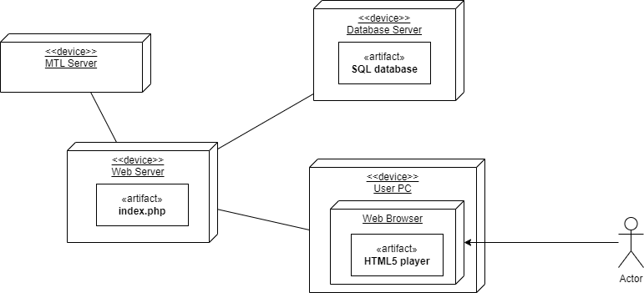

# Installation Procedure

1. Go to <https://www.phplist.org/download-phplist/>

1. Select Download ZIP option.
2. Extract all the files in the phplist.zip folder.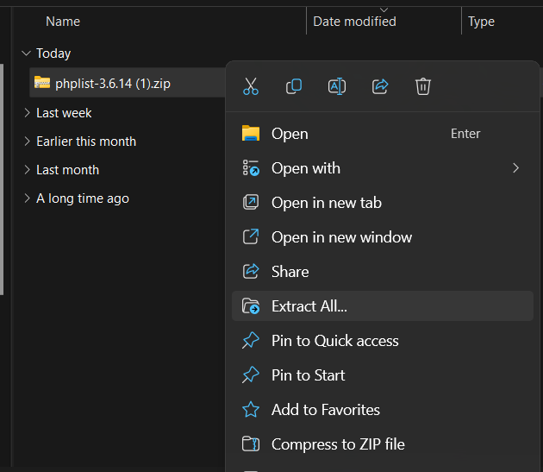
3. Move the lists folder to your development environment (in my case: www folder in laragon).

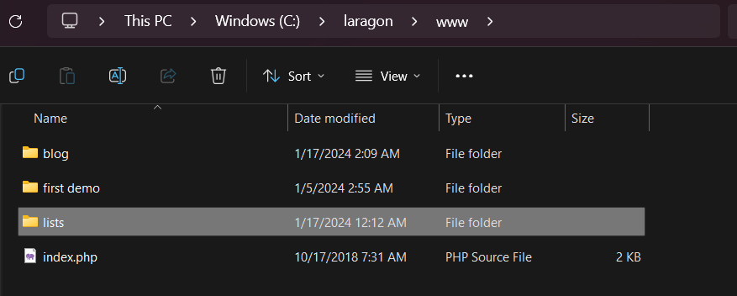

1. Run your phplist software.

# Testing and Verification

1. Procedures for Testing

* Confirm basic functionalities work (list creation, subscriber management).
* Test sending a sample email campaign for successful delivery.
* Check the web interface on different devices for usability.
* Ensure phpList communicates properly with the chosen database.
* Verify smooth subscriber management operations.

2. Verification Steps

* Double-check configuration settings (database, email).
* Review error logs for and address reported issues.
* Confirm correct setup of the phpList database.
* Check cron job functionality for scheduled tasks.
* Verify SSL/TLS certificate validity for secure communication.
* Test emails to ensure proper delivery and subscriber management.

# Technical Support and Contact Information

Contact for Help:

Official Website: Visit phpList's official website.

Support Email: Drop an email to [support@phplist.com](mailto:support@phplist.com).

Community Forums: Chat with other users for help.

More Help Resources:

Documentation: Read the user guide on phpList's website.

Knowledge Base: Find FAQs and troubleshooting tips.

Community Forums: Discuss and learn from other users.

Social Media: Stay updated and connect with phpList on social media.